Text-quantity-color (javascript) Project pictures

Total images: 4

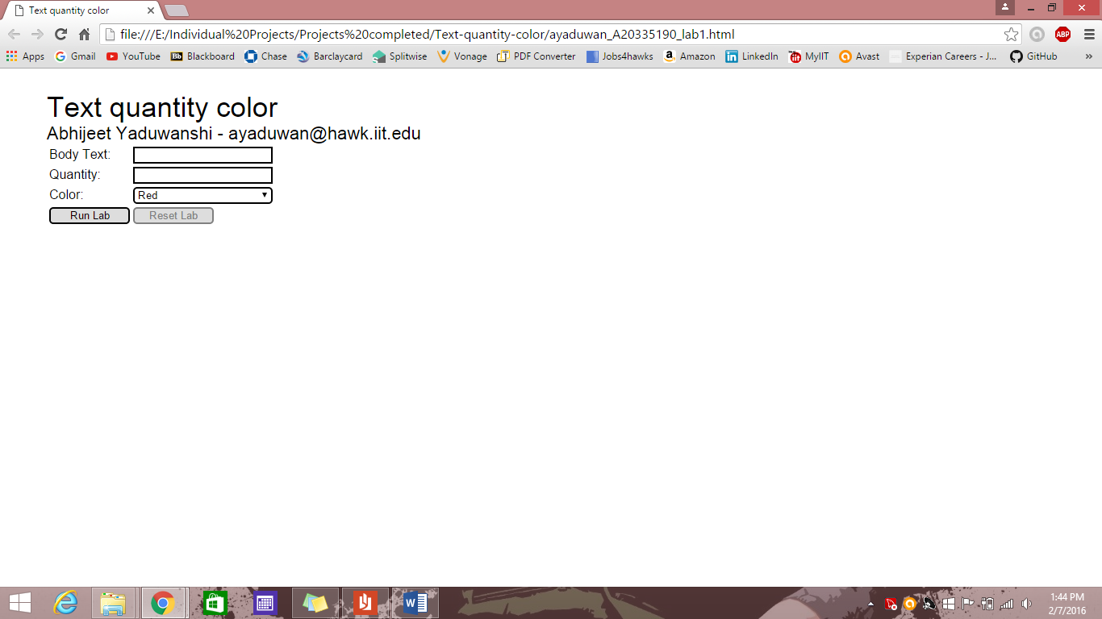

Fig 1: Home page

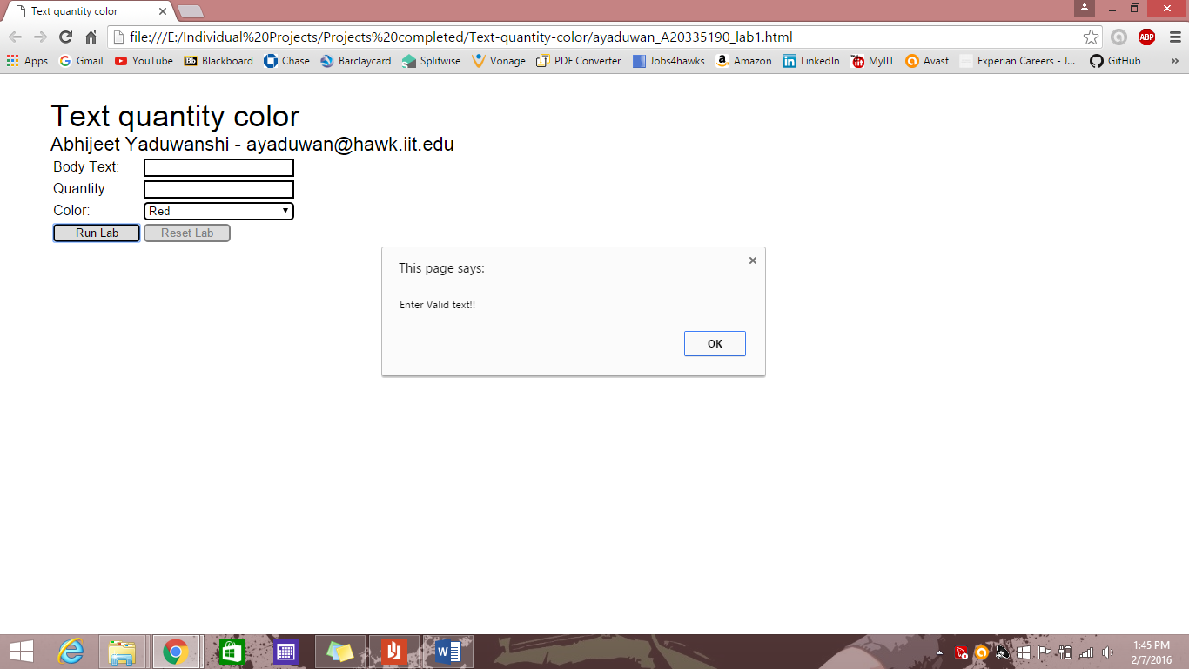

Fig 2: Alert message, enter valid text, checking for text in body text and integer value in quantity

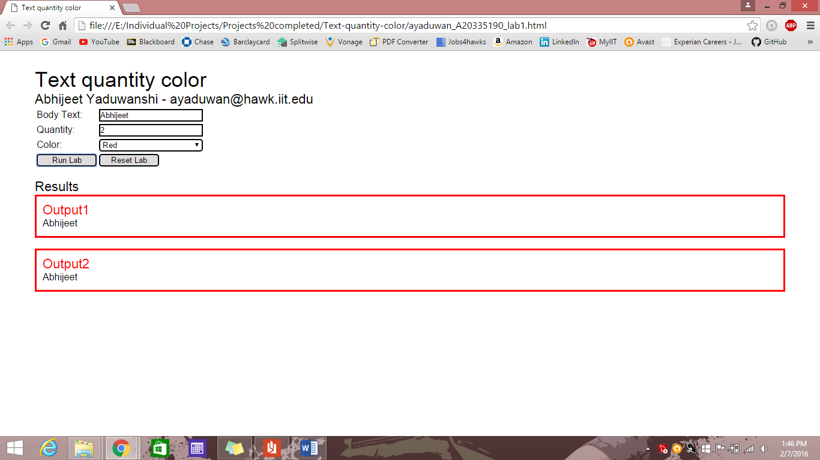

Fig 3: Final output with body text = “Abhijeet” quantity = 2 and color = “Red”

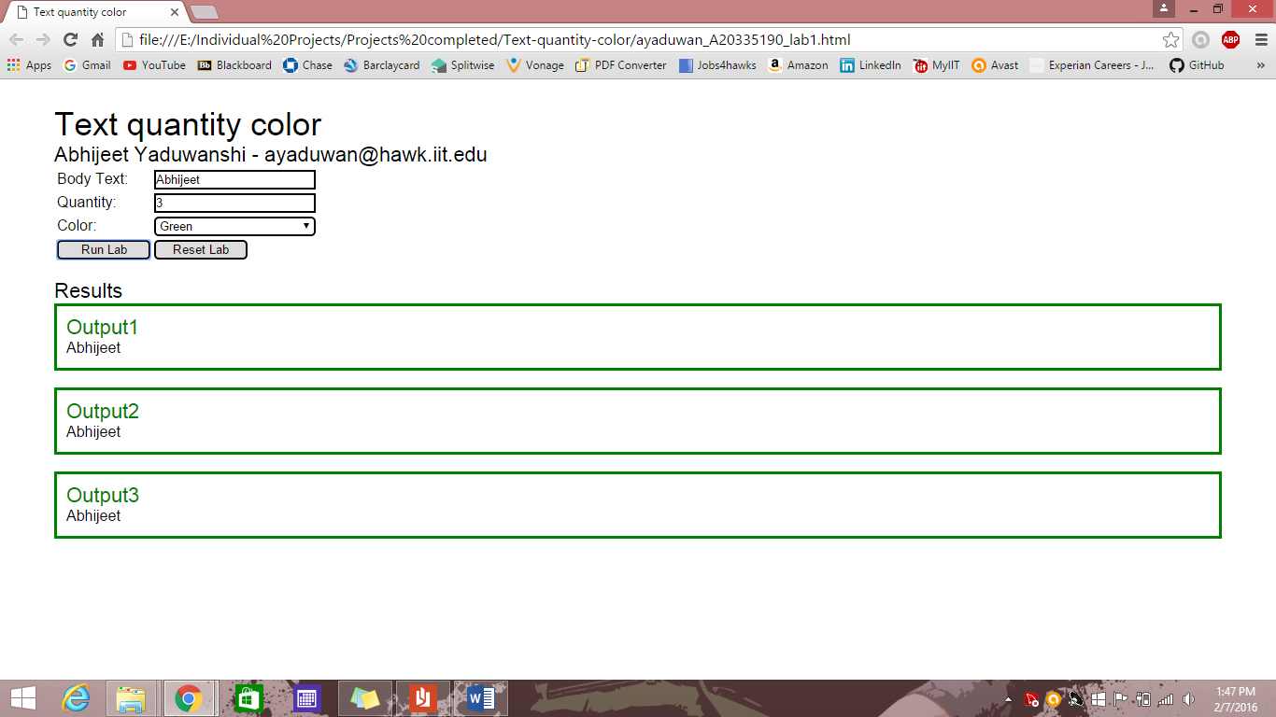

Fig 4: Change in the values without refreshing the page and changing quantity = 3 and color = “Green”